Driveway and Gutter Cleaning Companies in Edinburgh
Here in Scotland, we are used to bad weather with rain wind and snow playing havoc with our gutters and driveways. Here we list a number of companies that will clean your gutters and make your driveways look like new again!

Forth Pressure Clean Ltd
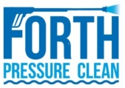

MJM Pressure Washing
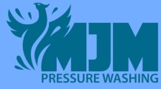

Mr Clever Clean
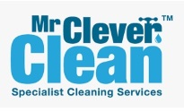

Eco Pressure Clean

